25.9.1 Editors - Properties Editor - Particle Tab - Emitter
Introduction 1
Workflow example 1

Introduction
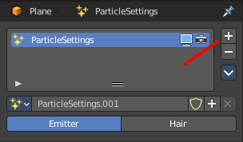
There are two types of particles. Emitted particles and hair. Emitted particles are used for things like fire, smoke, mist and many other animated effects. Hair is used for hair and fur effects, at characters for example.
This manual part is for particles of type Emitter.

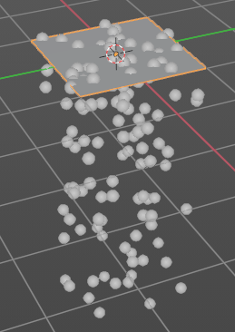
Workflow example
Create a plane.
Add a particle system.
Hit play. You will now see particles falling down from the plane.
Now you can start to tweak the settings until you are satisfied.

